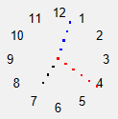Lesson 25 – JavaScript Events

**Goals of the lesson:**

Differentiate between and use both:

* **user caused events**.
* planned or **timed events**.

**JavaScript Timed Events:**

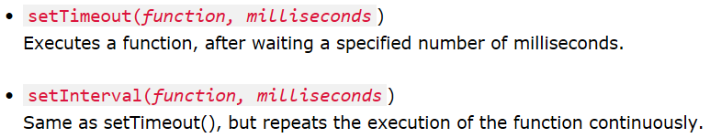

**Read and try:**

* JS Window object: <https://www.w3schools.com/js/js_window.asp>
* Timed events: <https://www.w3schools.com/js/js_timing.asp>
* Animations: <https://www.w3schools.com/js/js_htmldom_animate.asp>

**Task 1:**

* Open the **animation** program (created on lesson 20).
* Modify the program so that it uses timed events instead of loops.

**Task 2:**

* Open the **pexeso** example (from the previous lesson), both in your **browser** and inside **text editor**.
* Add an animation for every card swap